**Sprint 2**

**“BOOKSTORE AUTOMATION SYSTEM”**

**BSCS-VI**

**Group 2**

**Submitted to:**

**Mam Aatka Ali**

**Submitted by:**

**Noor us Sabah 161101**

**Mahnoor Jamil 161105**

**Fabyha Khan 161113**

**Rabia Kanwal 161118**

**Noor Fatima 161137**

**Maham Javad 161151**

**Amna Azhar 161366**



**Submission Date:**

**19th April 2019**

Test case for incorrect username and password:

The user should input correct password and username.

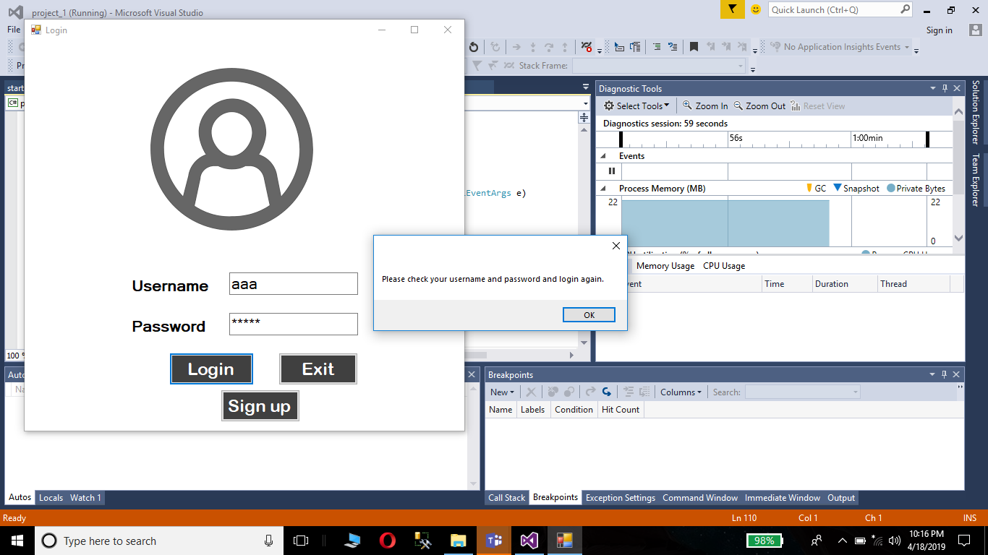

Test case for empty password field:

The user should not leave the password field empty.

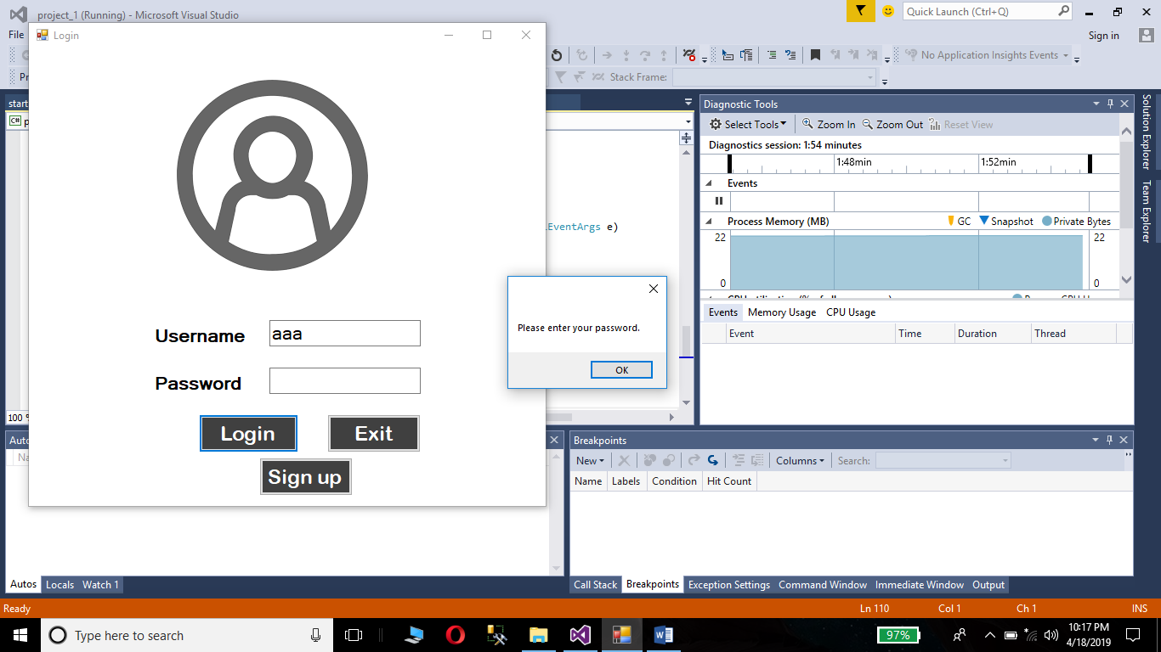

Test case for empty username field:

The user should not leave the username field empty.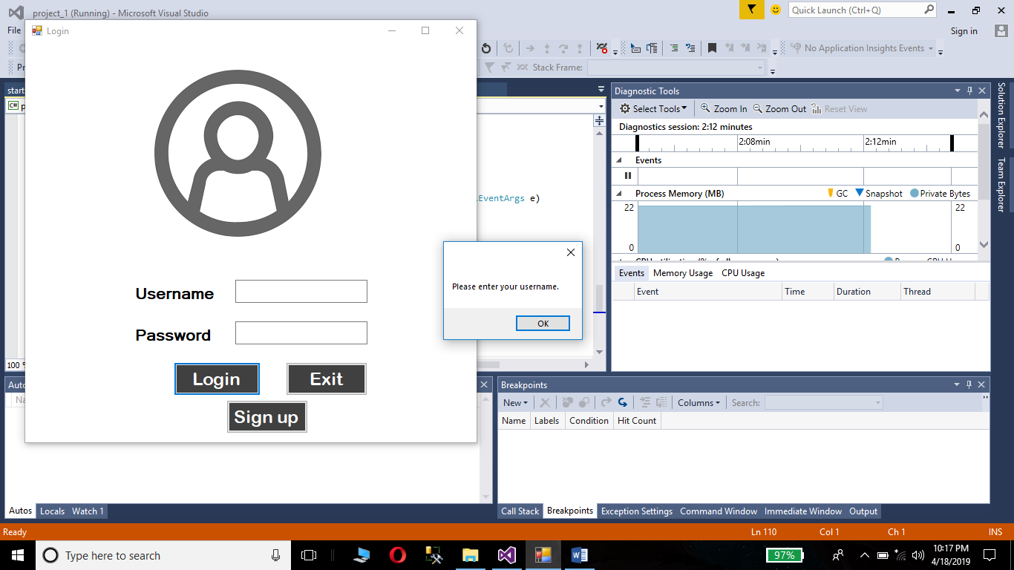

Test case for creating new employee with existing employee ID:

The user cannot add a new employee with an already existing employee ID.

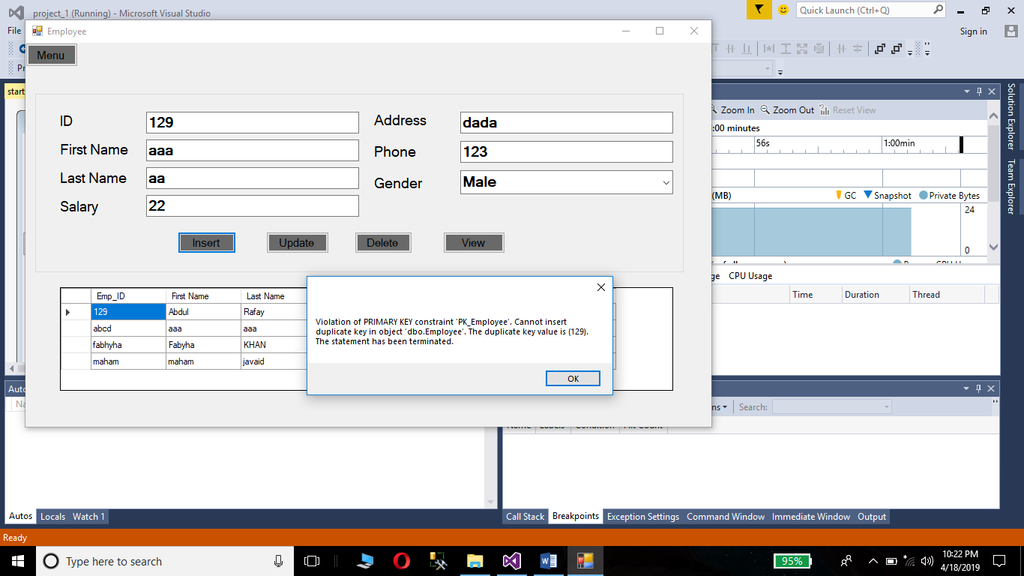

Test case for generating order with non-existing customer:

The user cannot create an order with a non-existing customer.

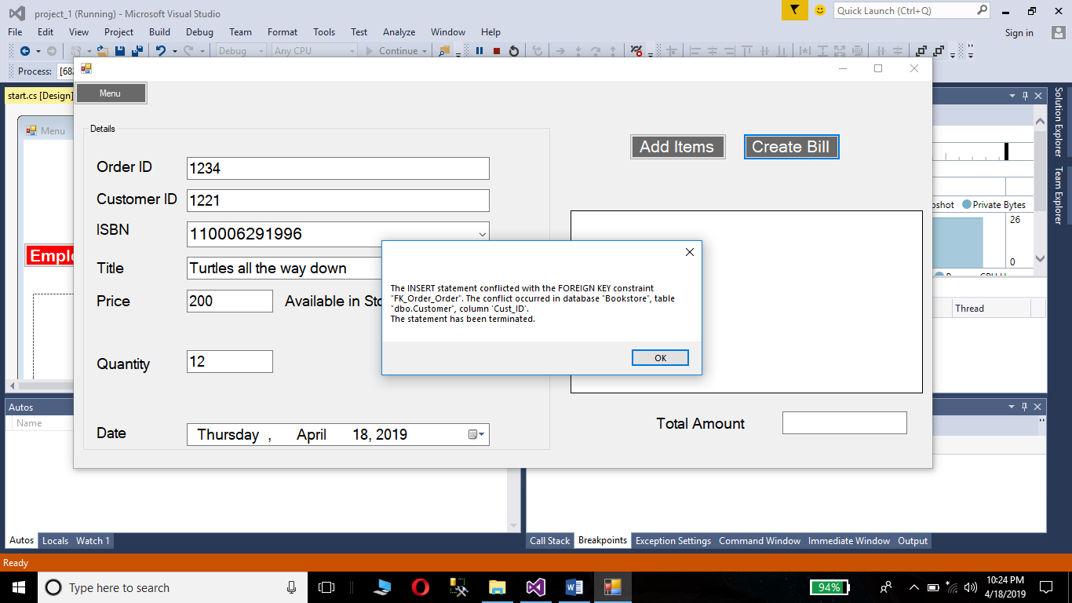

Test case for ordering books that are not available in stock:

The user cannot order books that are not available or are out of stock.

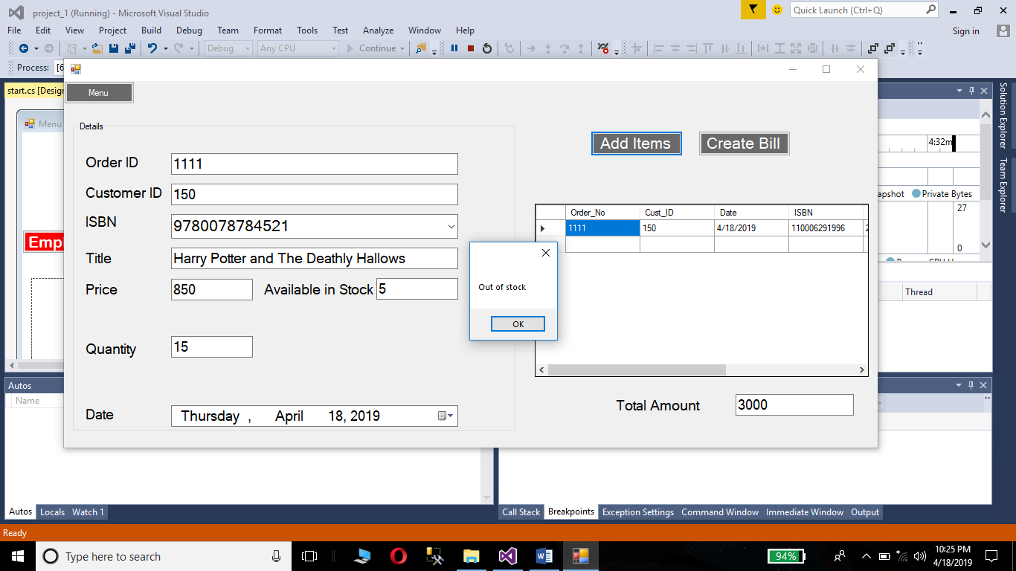

Test case for creating new vendor with existing vendor ID:

The user cannot create a new vendor with a existing vendor ID.

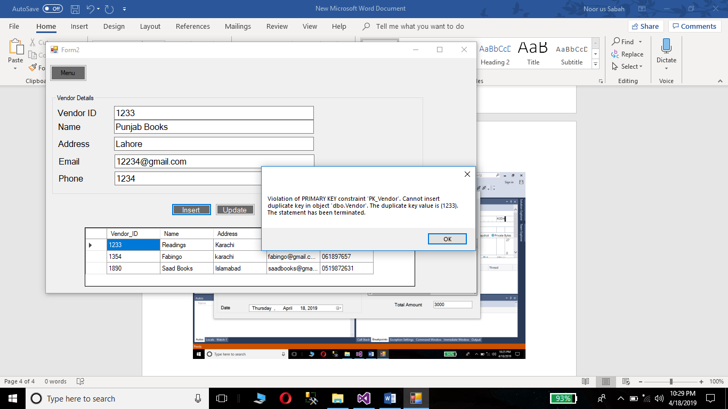

Test case for creating new customer with existing customer ID:

The user cannot create a new customer with an existing customer ID.

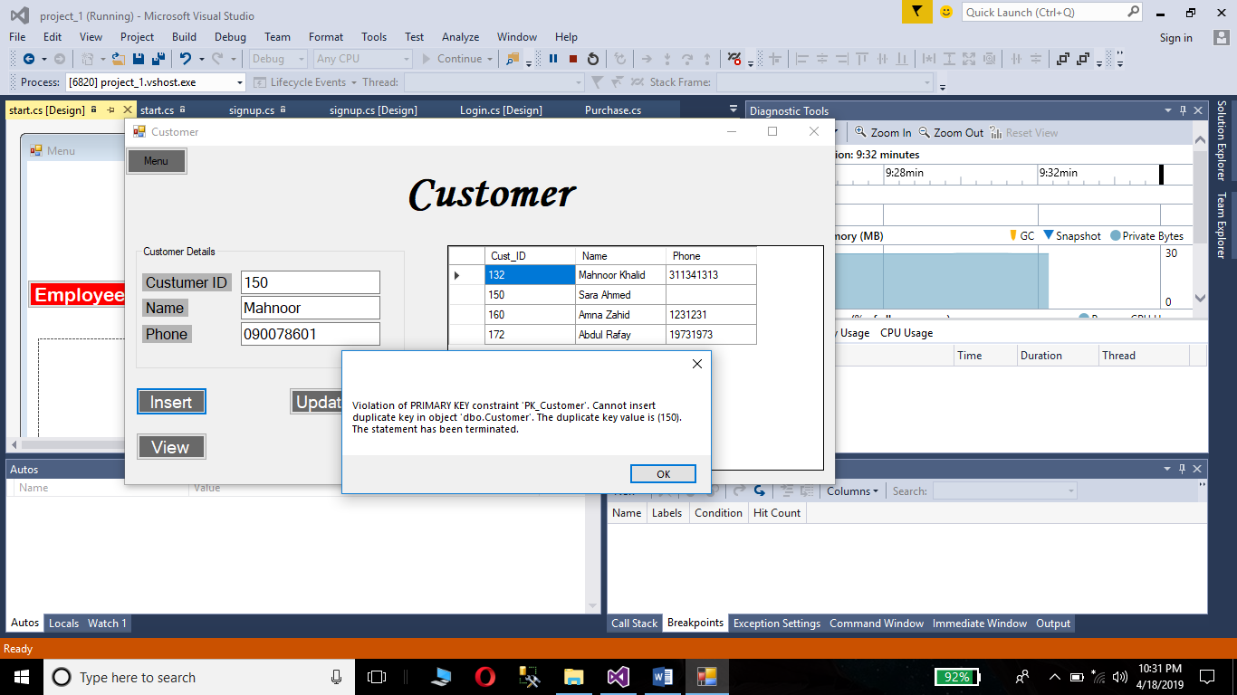

**Object Oriented Design:**